Campus Hiring Evaluation – Backend Task 1

College: K L University

Roll No: 2000031114

Name: Y Dhanush Kumar

<http://104.211.219.98/train/register> (POST)

This is an API to register your company with the John Doe Railway Server.

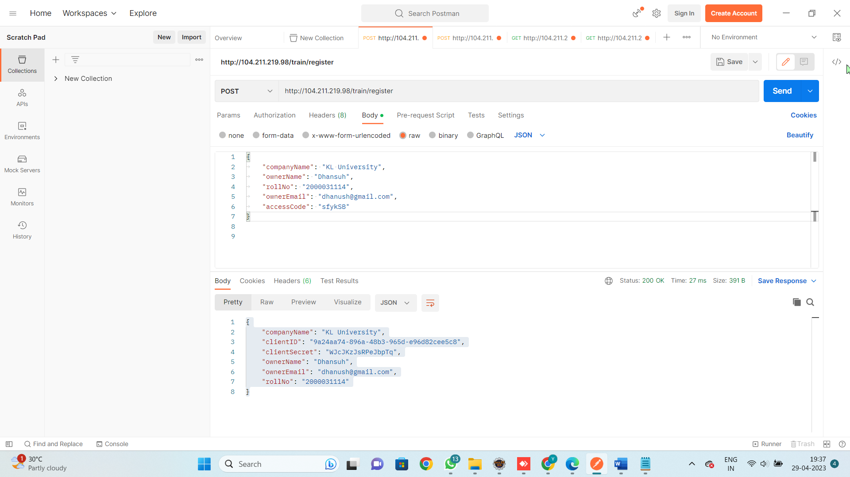

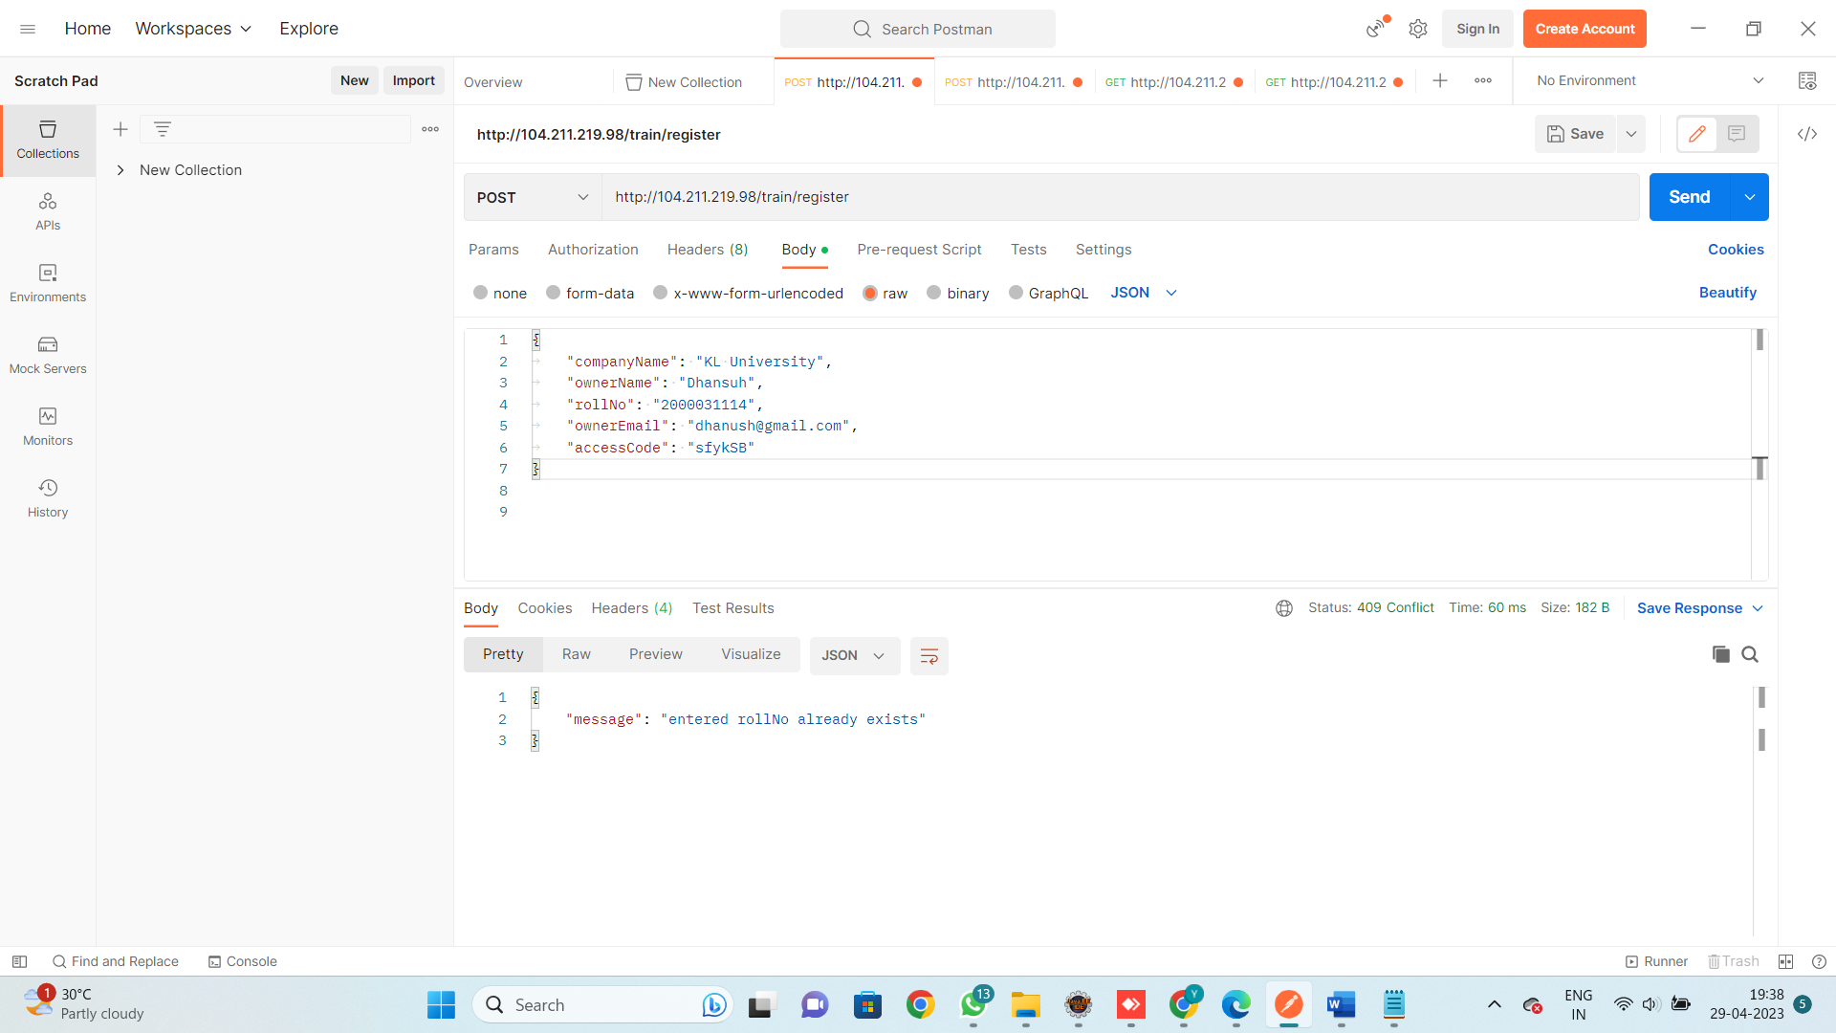

[http://104.211.219.98/train/auth](http://104.211.219.98/train/auth/) (POST)

This is an API to obtain the Authorisation Token for your company from the John Doe Railway Server.

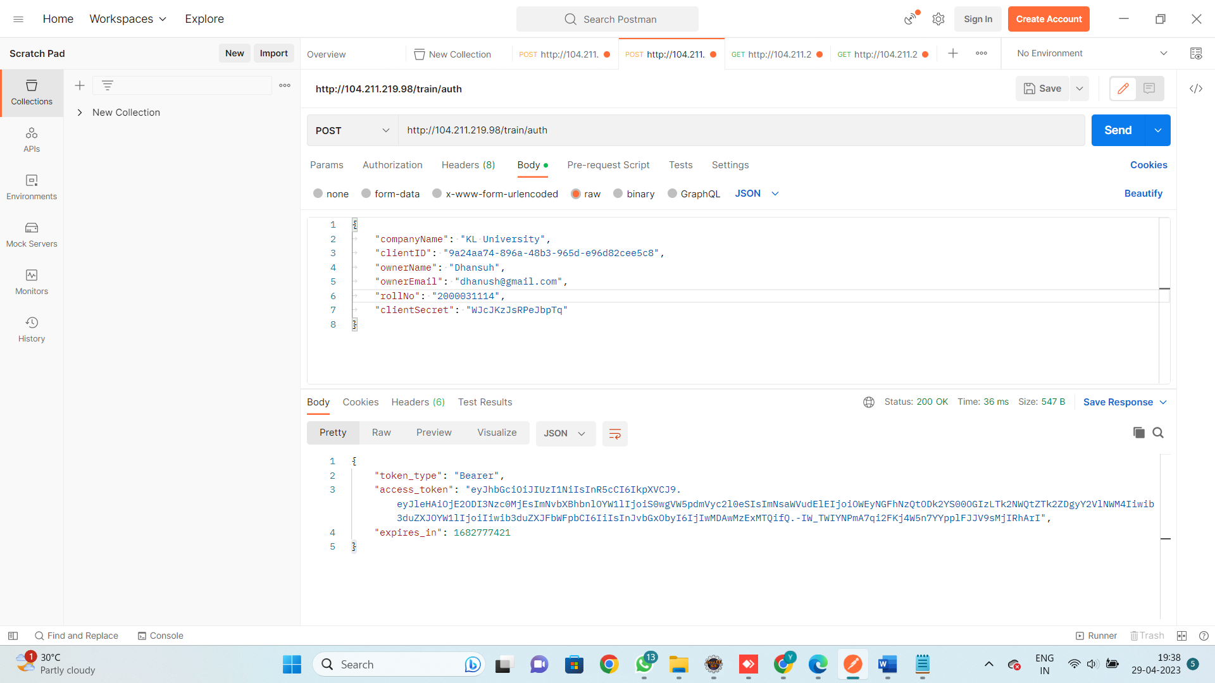

### <http://104.211.219.98/train/trains> (GET)

This is an API which returns all the train details from the John Doe Railway Server. This is a protected route and requires you to provide the Authorisation Token in the Header.

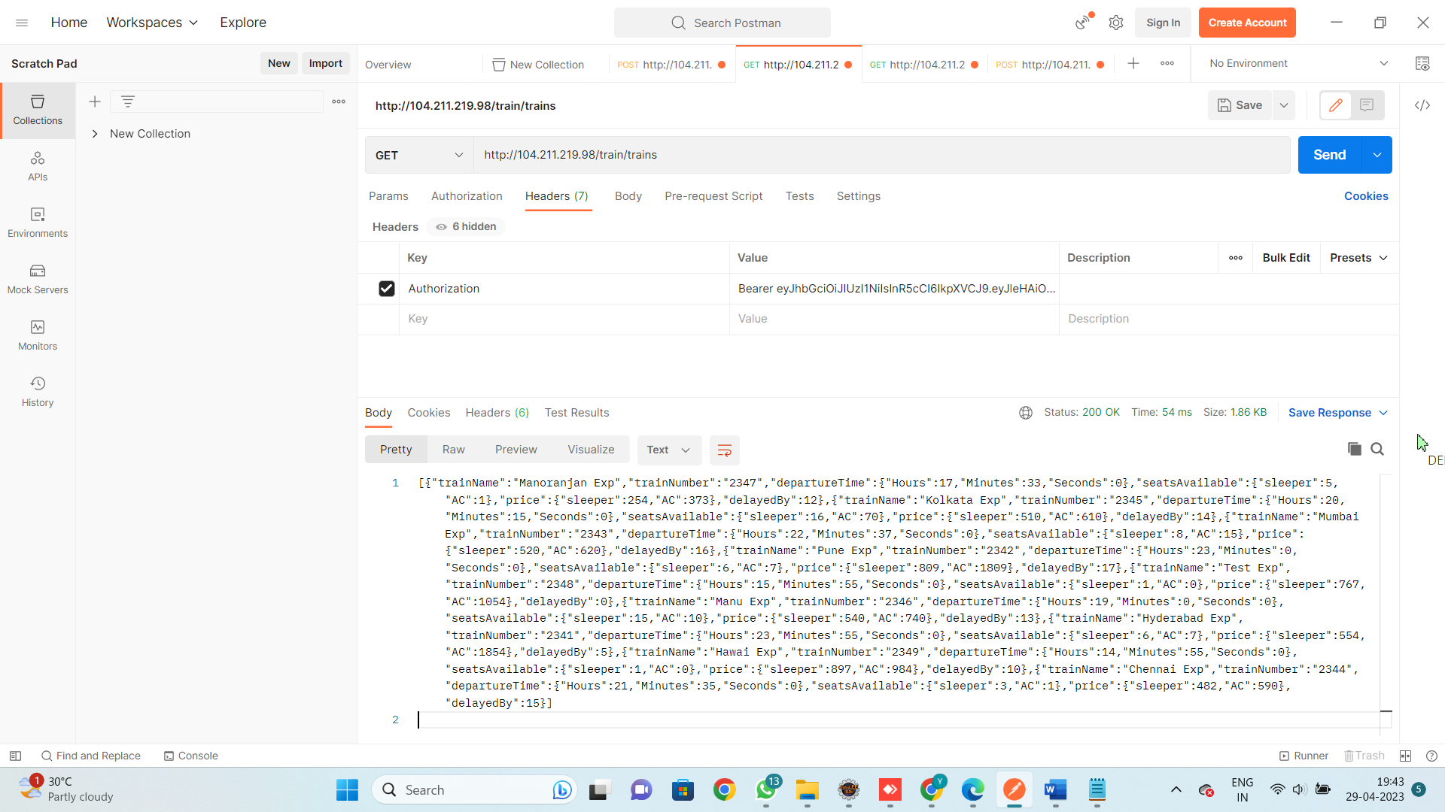

### [http://104.211.219.98/train/trains/2344](http://104.211.219.98:80/interview/trains/2344) (GET)

This is an API which returns the details of a **particular train** from the John Doe Railway Server. This is a protected route and requires you to provide the Authorisation Token in the Header.

